

**Report**

**Course Name:** Connect with Community and Nature

**Course code:** AOC101

**Year:** 2nd

**Semester:** 4th

**Session:** 2017-18

**Discipline:** Activity Oriented Course

**Name :**  Biren Sharma

**Enrollment No. :** U101116FCS246

**Black-rumped Flame back**

The Black-rumped Flame back or Lesser Golden-upheld Woodpecker (Dinopium benghalense) is a woodpecker discovered broadly disseminated in South Asia. It is one of only a handful couple of woodpeckers that are seen in urban regions, it has a trademark rattling-whinnying call and an undulating flight. It is the main brilliant sponsored woodpecker with a dark throat and dark posterior.

Description:

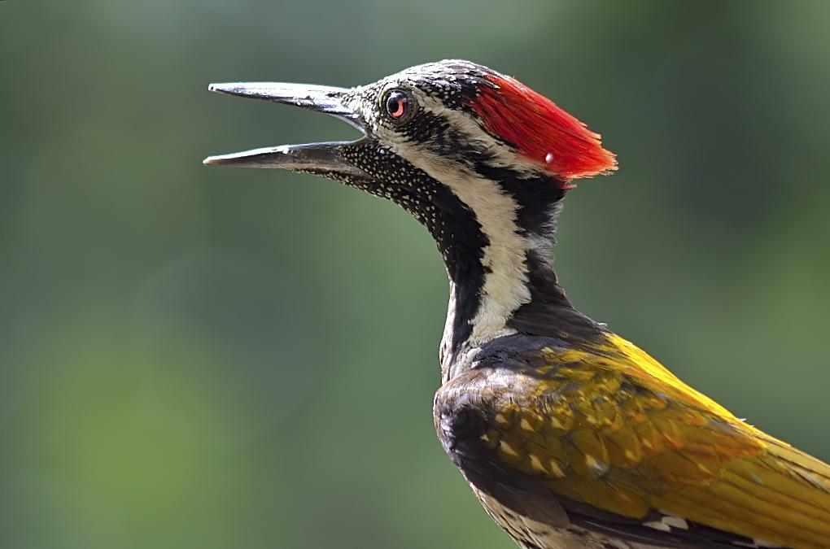

The Black-rumped Flameback is an expansive animal groups at 26– 29 cm long. It has an ordinary woodpecker shape, and the brilliant yellow wing coverts are particular. The posterior is dark. The underparts are white with dull chevron markings. The dark throat finely set apart with white quickly isolates it from other brilliant sponsored woodpeckers in the Indian locale. The head is whitish with a dark scruff and throat, and there is a greyish eye fix.

It has a strong tail to offer assistance against tree trunks, and feet, with two toes pointing forward, and two in turn around. The long tongue can be shot forward to get bugs. Females have a dark fore crown spotted

with white, with red just on the back peak. Youthful feathered creatures resemble the female, however more blunt.

Leucistic feathered creatures have been recorded. Two examples of male winged animals from the northern Western Ghats have been noted to have red-tipped quills on the malar district nearly shaping a malar stripe.

Distribution / Habitat:

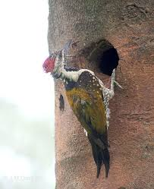

The Black-rumped Flameback is a boundless and basic inhabitant raiser in a lot of South Asia.

It is discovered fundamentally on the fields going up to a height of around 1200m in Pakistan, India south of the Himalayas and east till the western Assam valley and Meghalaya, Bangladesh and Sri Lanka.

It is related with open woods and development. They are regularly observed in urban territories with lush roads. It is to some degree uncommon in the Kutch and abandon area of Rajasthan.

Diet / Feeding:

This species is ordinarily found in sets or little gatherings and now and then joins blended species rummaging herds.

They scavenge from the beginning the overhang. They feast upon creepy crawlies for the most part bug hatchlings from under the bark, visit termite hills and once in a while eat nectar. As they make jumping developments around branches, they frequently hide themselves from potential predators.

They adjust well in human-changed living spaces making utilization of fake developments fallen leafy foods nourishment scraps.

Breeding:

The rearing season fluctuates with climate and is amongst February and July.

They every now and again drum amid the reproducing season. The home gap is generally unearthed by the feathered creatures and has a flat passageway and slips into a hole. Now and again winged animals may usurp the home gaps of different flying creatures. Homes have additionally been noted in mud.

The eggs are laid inside the unlined depression. The typical grasp is three and the eggs are prolong and reflexive white. The eggs bring forth after around 11 days of brooding. The chicks leave the home after around 20 days.

**Indian eagle-owl**

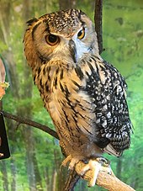

The Indian hawk owl, also called the stone falcon owl or Bengal bird owl (Bubo bengalensis), is a types of vast horned owl confined to the Indian Subcontinent. They were prior regarded as a subspecies of the Eurasian hawk owl. They are found in uneven and rough clean woods, and are generally found in sets. They have a profound thunderous blasting call that might be heard at sunrise and sunset. They are ordinarily expansive owls, and have "tufts" on their heads. They are sprinkled with dark coloured and dim, and have a white throat fix with dark little stripes.

Description:

This species is frequently viewed as a subspecies of the Eurasian bird owl bubo and is fundamentally the same as in appearance. The facial circle is unmarked and has a dark fringe, a component that is significantly weaker in the Eurasian shape. The base of the primaries is unbanded and rufous. The tail groups have the tawn groups more extensive than the dark ones. A huge pale scapular fix is unmistakable on the collapsed wing. The internal hooks are the longest. The last joint of the toes are unfeather.

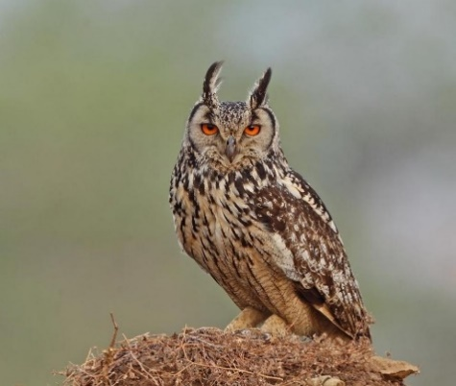

Distribution / Habitat:

They are found in clean and light to medium woods yet are particularly observed close rough places inside the terrain of the Indian Subcontinent south of the Himalayas and underneath 1,500 meters (5,000 ft) height. Muggy evergreen backwoods and to a great degree parched zones are dodged. Shrub secured rough hillocks and gorges, and soak banks of waterways and streams are most loved frequents. It spends the day under the haven of a shrubbery or rough projection, or in a vast mango or comparative thickly foliaged tree close towns. This substantial owl with the unmistakable face, huge front oriented eyes, horns and profound thunderous call is related with various superstitions. In the same way as other vast owls, these are considered flying creatures of sick sign. Catch of these flying creatures is illicit.

Diet / Feeding:

When it comes to noshing, they like their nourishment substantial. They generally centre around rodents, for example, mice and rats yet in addition eat crabs, creatures of land and water, reptiles and even different winged creatures, however typically just in winter. Indian bird owls are now and then observed as useful animals, because of their

inclination for eating rodents. Since they eat loads of rodents, they assist dispose of aggravations to cultivating.

**Breeding:**

These owls will breed from February to April, yet this may differ locally amongst October and May.

The home is generally a shallow rub on exposed earth. This might be on a secured shake edge, stream bank, or a break in a precipice that is in a gorge. They have likewise been known to settle on the ground under a shrub, or between rocks on a slant. 2-4 white eggs are laid, averaging 53.6 x 43.8mm. They are hatched by the female for 35 days.

*********************